Incident Playbook: Risky User & Risky Sign-In Detected
Note: For Medium and Low Priority alerts please do not immediately reset the password and block the account ,before that try to connect with user to confirm the legitimate .

Objective:
This playbook outlines the steps to investigate and mitigate incidents related to risky users and risky sign-ins detected in Microsoft Entra ID Protection and Defender for Identity. The goal is to protect sensitive information and prevent potential security breaches.

Step 1: Assess Risky User and Risky Sign-In Status
- Monitor Risk Detection Logs:
Access the Azure admin portal at https://Portal.azure.com/. And Open Entra ID Protection to review the following logs:
  - Risky User: Examine the affected user’s risk status (e.g., compromised credentials, unfamiliar sign-in location).
  - Risky Sign-In: Analyze the sign-in attempts that are flagged as risky.
  - Risk Detection: Investigate the details of any detected risks (e.g., impossible travel, anonymous IP address).
Actions:
  - Collect relevant logs for the user’s risky sign-ins.
  - Document any unusual sign-in behavior or anomalies.
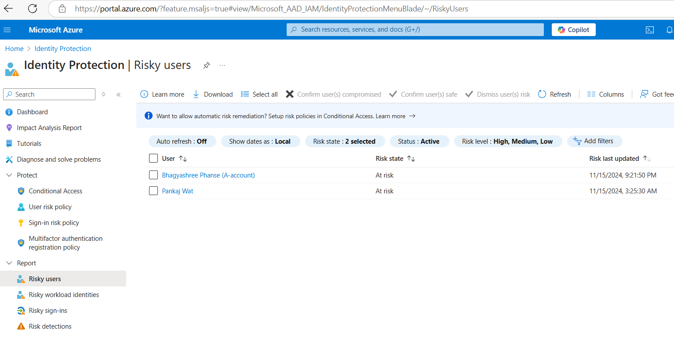

Step 3: Contact the User and Initiate Account Protection
- Immediate Communication with the User:
  - If User is Available:
Contact the user immediately via Microsoft Teams and inform them of the ongoing investigation and any risks detected on their account.
  - If User is Unresponsive:
In case of no response on Teams, escalate the issue by emailing the Help Desk team for assistance in reaching the user.
- Action Items to Secure the Account:
  - Force Password Reset: Reset the user’s password immediately to prevent further unauthorized access.
  - Revoke MFA Sessions: Revoke any active multifactor authentication (MFA) sessions to invalidate any session tokens that may be compromised.
Important Note:
  - VIP User Consideration: If the affected user is a VIP or high-priority user, immediately escalate the issue to [Sreejith's name] for further handling before taking action.
Next Steps:
  - Review the user’s activity logs during this step to look for any suspicious behaviour or unauthorized actions.

Step 4: Block User Account (If Compromised)
- Immediate Account Block:
If the user confirms their account has been compromised, or if the issue is identified after hours and Help Desk support is unavailable, proceed to block the user’s account.
Important Consideration:
  - VIP User: Before blocking the account, confirm that the user is not a VIP. If they are, immediately escalate the issue to [Sreejith's name] for further action.
Actions:
  - Block the affected user account to prevent any unauthorized access or lateral movement.
Next Steps:
  - Review logs and monitor for any signs of ongoing malicious activity.

Step 5: Investigate Lateral Movement and Forensic Artifacts
- Investigate Potential Lateral Movement:
  - Use Microsoft Defender and Azure Logs:
Leverage Microsoft Defender, Azure audit logs, and activity logs to investigate whether the compromised account has been used for lateral movement or to access other resources.
Actions:
  - Identify any unauthorized access to sensitive systems, applications, or data.
  - Gather forensic evidence to support a full investigation and help prevent future incidents.

Next Steps:
  - Document all findings and escalate the case to the appropriate security or incident response team for further action if necessary.

Summary of Key Actions:
- Investigate risky sign-ins and user status in the Entra portal.
- Communicate with the user to confirm account status and initiate account protection.
- Block the account if compromised, with escalation for VIP users.
- Investigate lateral movement and gather forensic evidence for a full incident review.

